Database Management

WANG Meng王萌

Email: [mengwang7@lu.edu.hk](mailto:mengwang7@lu.edu.hk)

Phone: 26168136

1. General

meet her at office time at Wong Administration Building

Office Hour: NOT mentioned

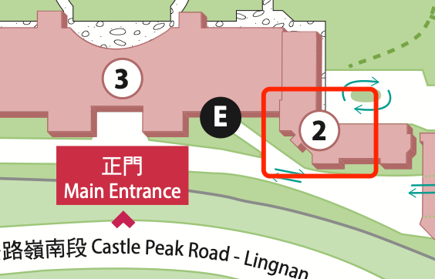

## Assessment

attendance 5%

assignment 25%

project 10%

examination 60%

GAI is permitted in assignment, case study in this course but should DECLARE the use of GAI.

## Required/Essential Readings

I think better to practice other than read of this course

目录

第1章 General - 1 -

1.1 Assessment - 1 -

1.2 Required/Essential Readings - 1 -

第2章 Week 1 Lecture 1 - 3 -

2.1 type of data - 3 -

2.2 Relationship between database and computer system - 3 -

2.3 what is database? - 3 -

2.4 what is database management system? - 4 -

2.5 what is database system and relationships among them? - 4 -

2.6 Three database operations - 5 -

2.7 Three level architecture - 5 -

2.8 principles of transactions - 5 -

2.9 Rough view of NoSQL - 6 -

2.10 Definition of concepts - 6 -

2.11 All types of ER relation - 6 -

第3章 Week 2 Lecture 2 - 7 -

3.1 Translate E/R diagram to Relational Schema - 7 -

第4章 Week 3 Lecture 3 - 8 -

4.1 Draw E/R diagram to Relational Schema - 8 -

4.2 Integrity Constraints - 8 -

第5章 Week 4 Lecture 4 - 9 -

5.1 Integrity Constraints 完整性约束 - 9 -

5.2 Attribute Constraint - 9 -

第6章 Week 5 Lecture 4,5 - 10 -

6.1 SQL Structured Query Language - 10 -

6.2 DDL Data Definition Language - 10 -

6.3 DML Data Manipulation Language - 10 -

6.4 DQL Data Query Language - 10 -

6.5 NULL Value Comparison - 10 -

6.6 Sub string Pattern Matching - 10 -

6.7 Aliasing and Renaming - 11 -

6.8 Key Word - 11 -

6.9 Aggregate Functions - 11 -

第7章 Week 6 Lecture 6 - 12 -

7.1 GROUP BY - 12 -

7.2 HAVING - 12 -

7.3 JOIN Tables - 13 -

7.3.1 INNER JOIN - 13 -

7.3.2 LEFT OUTER JOIN - 13 -

7.3.3 RIGHT OUTER JOIN - 13 -

7.4 Views in SQL - 13 -

7.5 Summary of SQL Syntax - 13 -

第8章 Week 7 Lecture 6,7 - 15 -

8.1 Relational Algebra - 15 -

8.1.1 Unary Relational Operations - 15 -

8.1.2 Binary Relational Operations - 15 -

8.1.3 Relational algebra operations from set theory - 15 -

8.1.4 Additional Relational Operations - 15 -

第9章 Week 8 Lecture 8 - 16 -

# Week 1 Lecture 1

## type of data

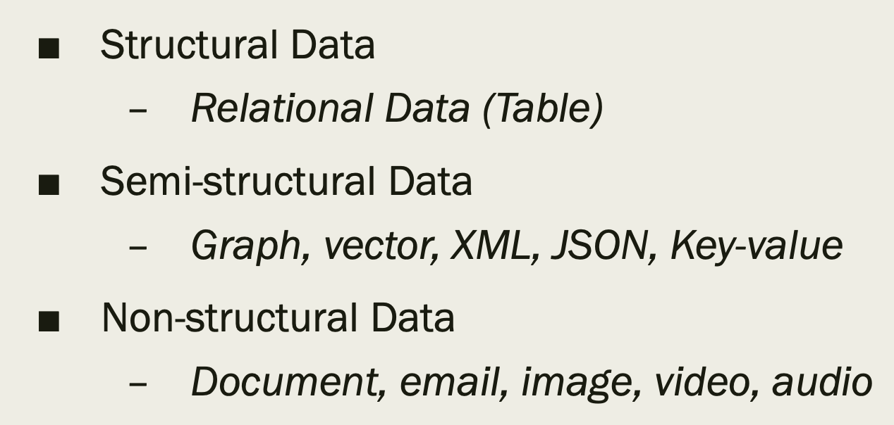

## Relationship between database and computer system

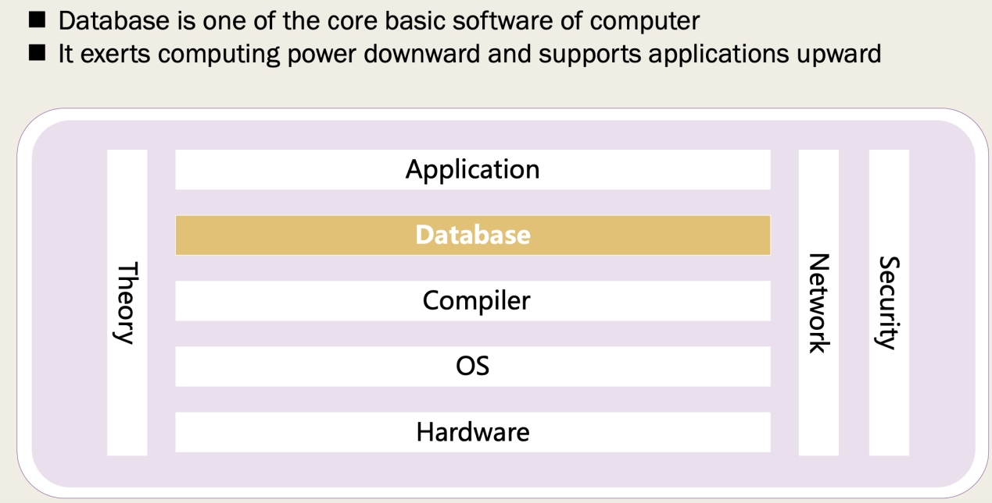

## what is database?

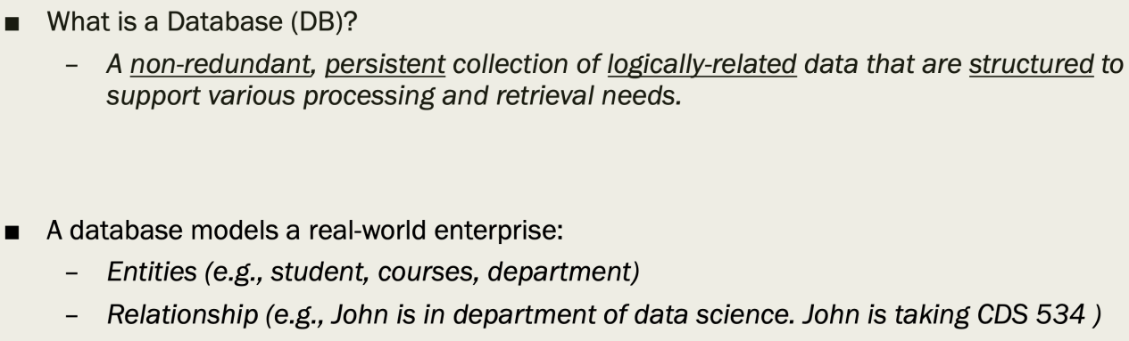

## what is database management system?

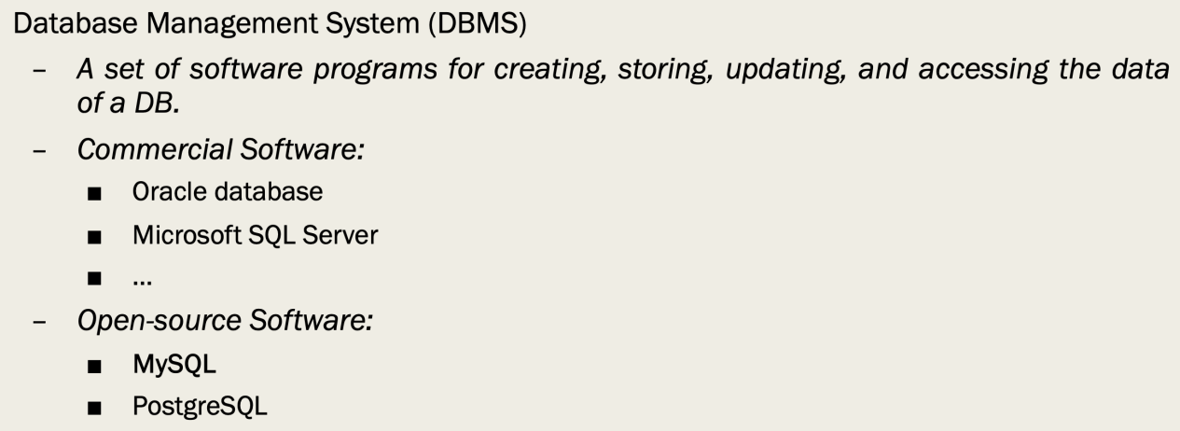

## what is database system and relationships among them?

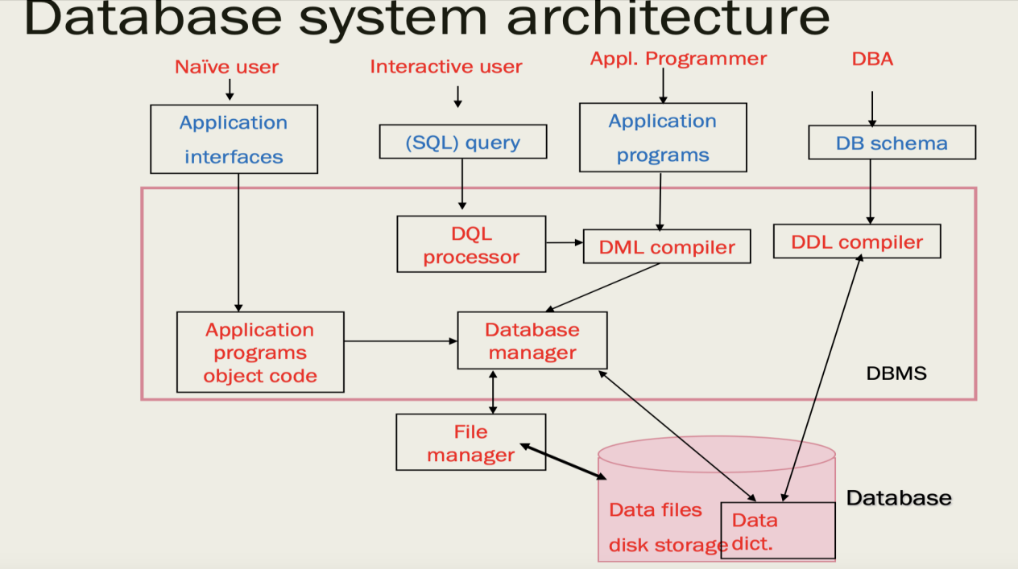

DB is a collection of data managed by a software called DBMS.

DB with DBMS plus stakeholders together formed the whole DBS.

## Three database operations

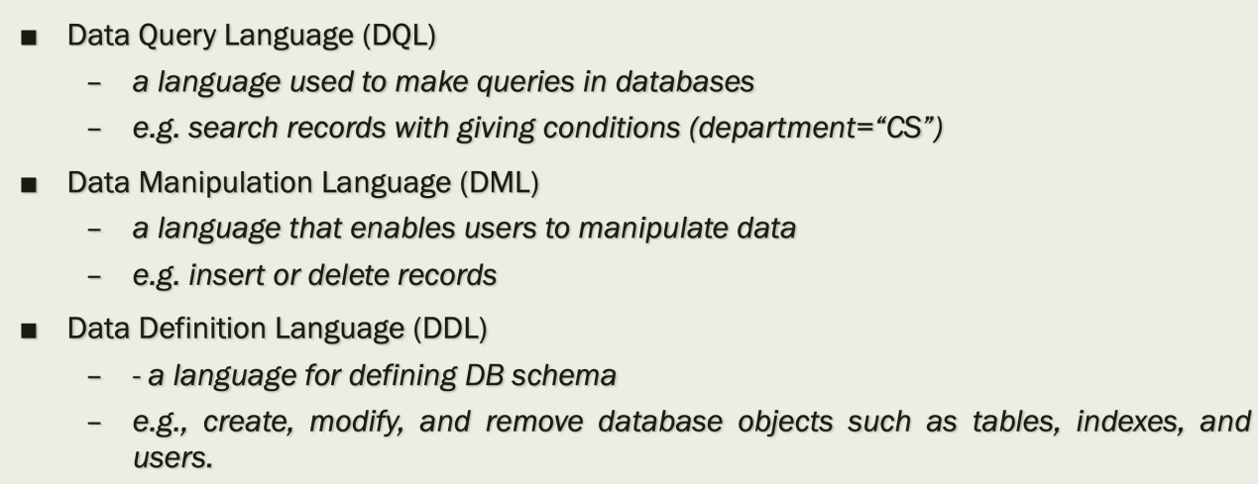

## Three level architecture

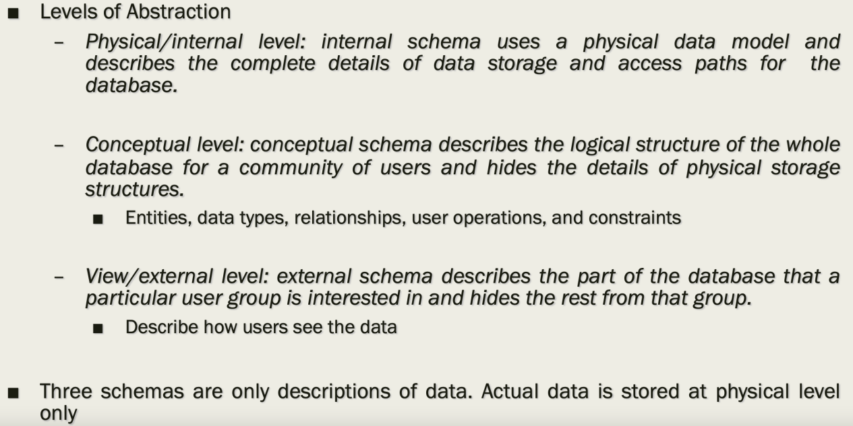

## principles of transactions

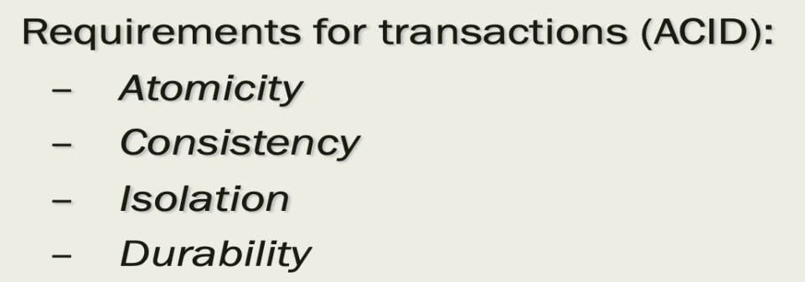

## Rough view of NoSQL

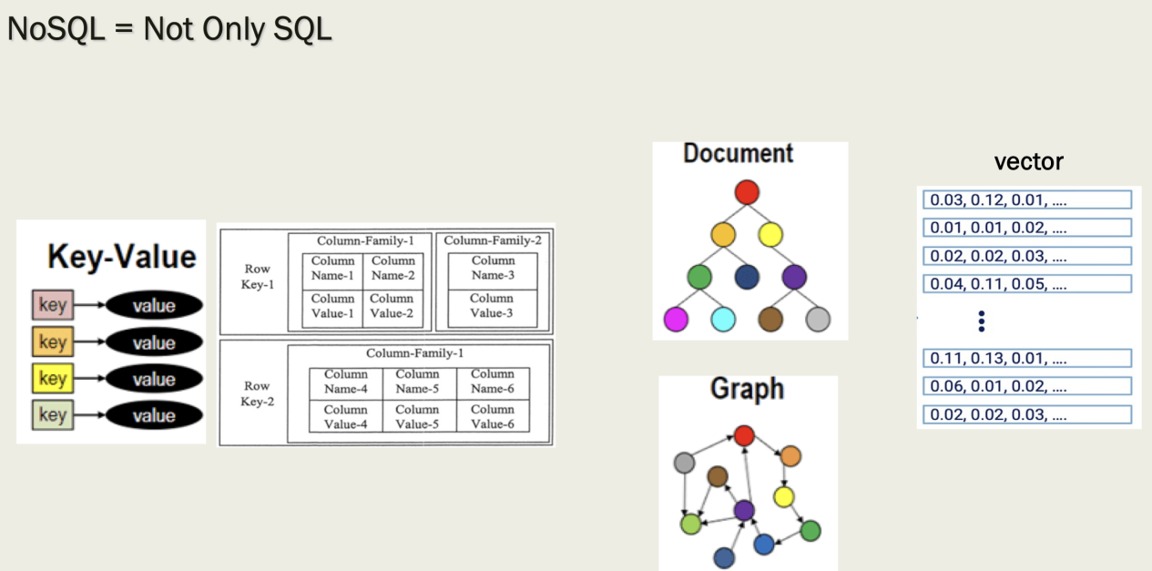

## Definition of concepts

entity: Specific object

entity set: Abstraction of same entities

relationship: Association among some entities

relationship set: Abstraction of same relationships

attribute: Piece of information describing an entity

## All types of ER relation

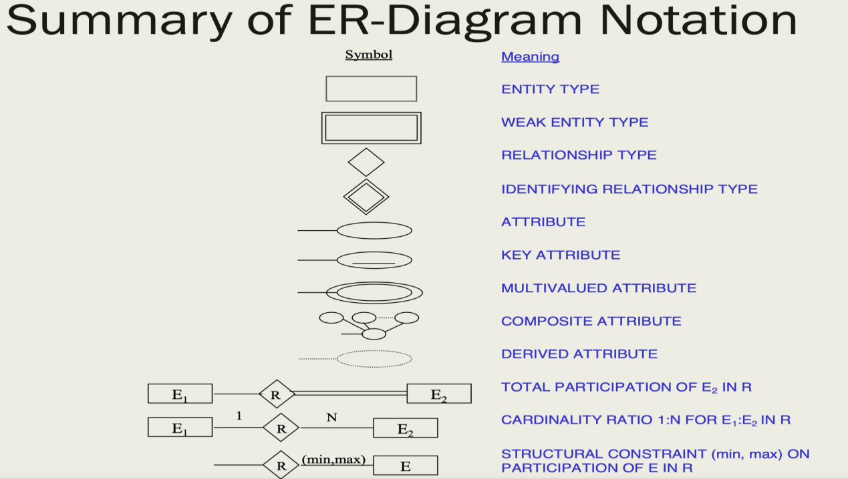

# Week 2 Lecture 2

## Translate E/R diagram to Relational Schema

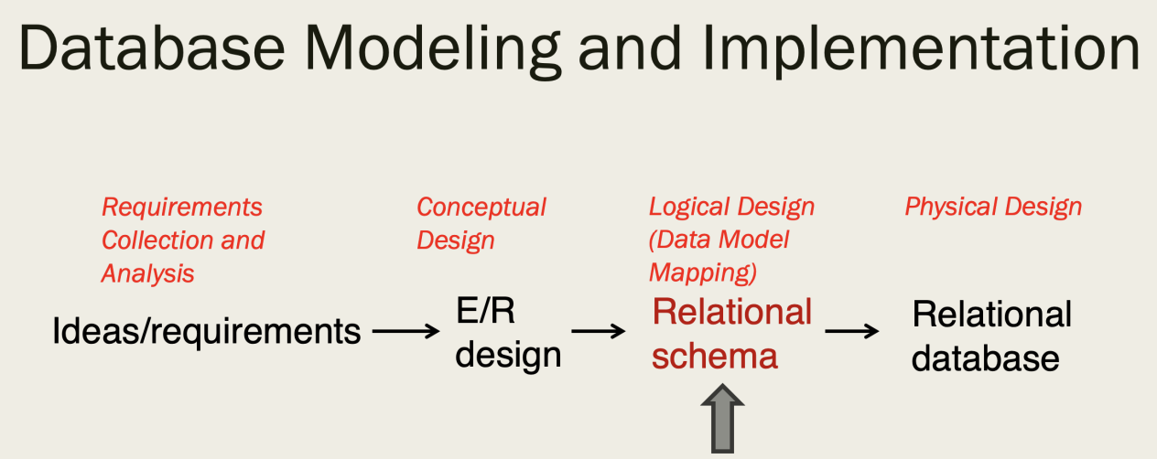

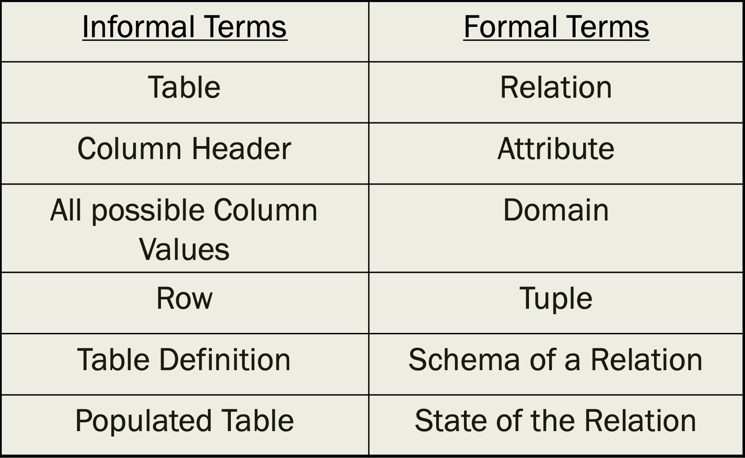

# Week 3 Lecture 3

## Draw E/R diagram to Relational Schema

1:1relation draw only one schema

1:n or n:n draw three schemas

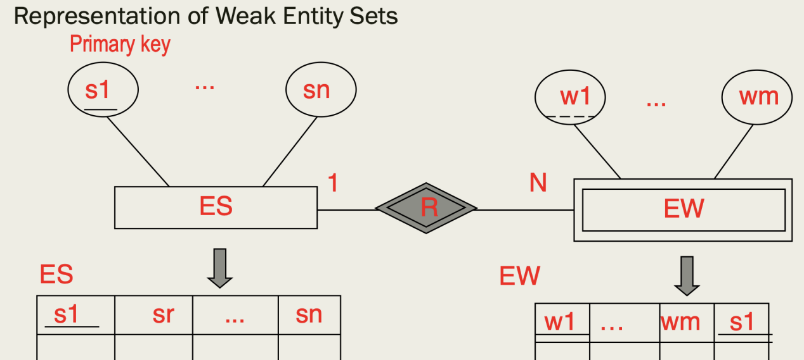

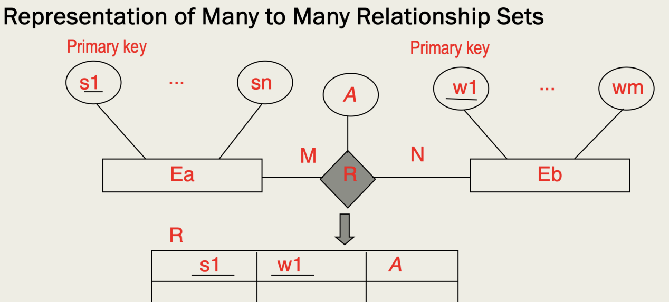

## Integrity Constraints

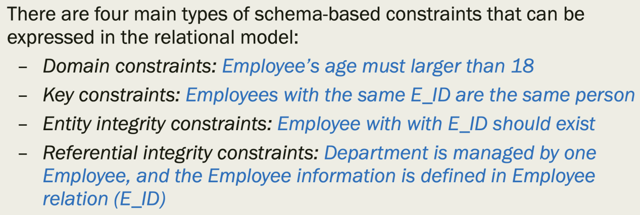

# Week 4 Lecture 4

## Integrity Constraints 完整性约束

Domain Constraint: Every value in a tuple must be an atomic value from the domain of its attribute

**Key Constraint**: No two tuples have the same Primary Key value

Candidate Key: uniquely identify a row in a table with no redundant attributes

Primary Key: A chosen candidate key

Super Key: Candidate Key plus any other attributes

**Entity Integrity Constraint**: The primary key cannot have null value

**Referential Integrity Constraint**: Foreign Key constraint is the same as Primary Key; Foreign Key must match a Primary Key

## Attribute Constraint

NOT NULL

UNIQUE

PRIMARY KEY

FOREIGN KEY

CHECK

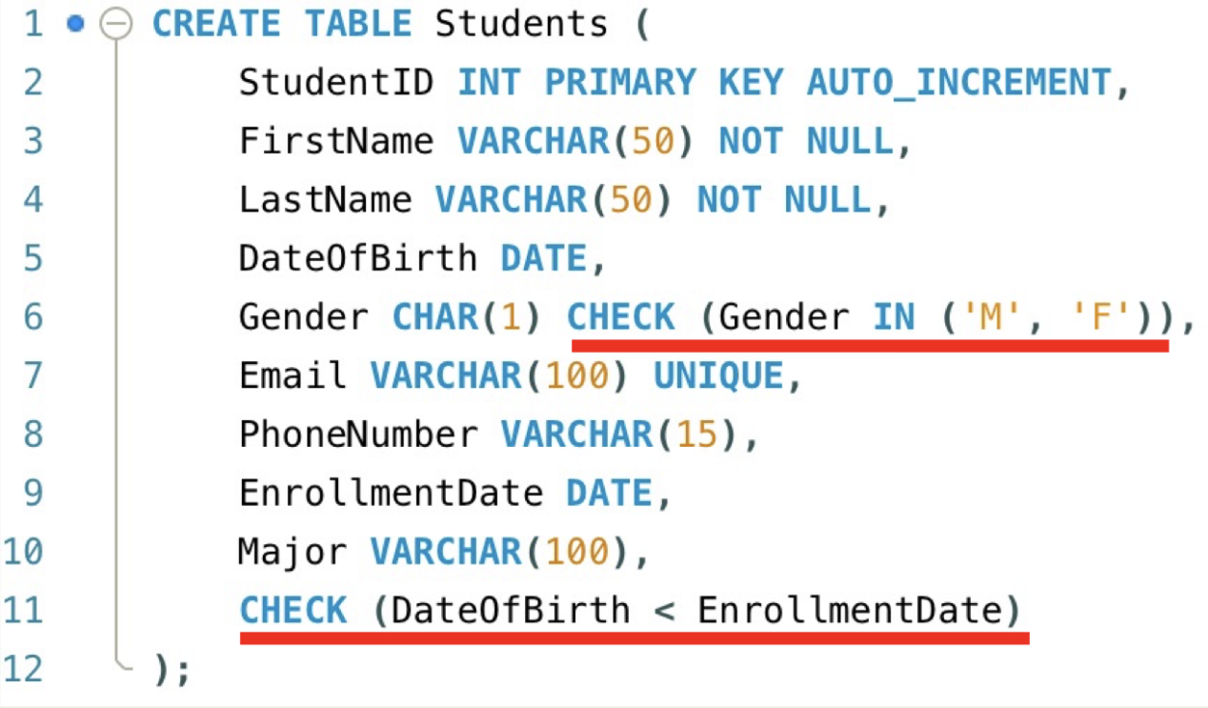

# Week 5 Lecture 4,5

## SQL Structured Query Language

Collection of DDL/DML/DQL

## DDL Data Definition Language

Commands include CREATE, ALTER, and DROP.

## DML Data Manipulation Language

Commands include INSERT, UPDATE , and DELETE.

## DQL Data Query Language

Commands include SELECT.

## NULL Value Comparison

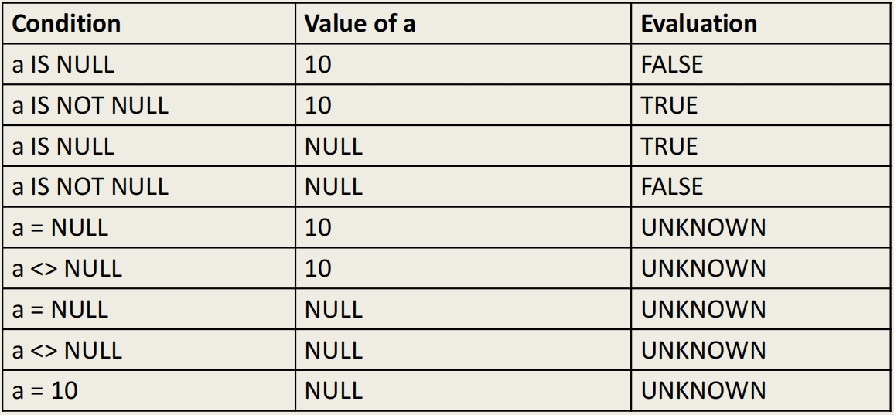

## Sub string Pattern Matching

percentage (%) replaces an arbitrary number of zero or more characters, and the underscore (_) replaces a single character.

SELECT Fname, Minit, Lname

FROM EMPLOYEE

WHERE Fname LIKE ‘%mm%’;

(Note: if we use ‘ _ _ mm%’, then it becomes a special case

## Aliasing and Renaming

Must declare alternative relation, called aliases or tuple variables using AS.

For each employee, retrieve the employee’s first and last name and the first and last name of his or her immediate supervisor.

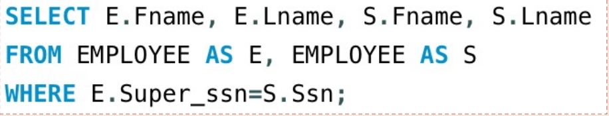

## Key Word

WHERE

ORDER BY

DISTINCT

HAVING

Nested Queries: IN

Nested Queries: ANY, ALL

EXISTS/ NOT EXISTS

## Aggregate Functions

COUNT, SUM, MAX, MIN, AVG

# Week 6 Lecture 6

## GROUP BY

The grouping attributes should also appear in the SELECT clause.

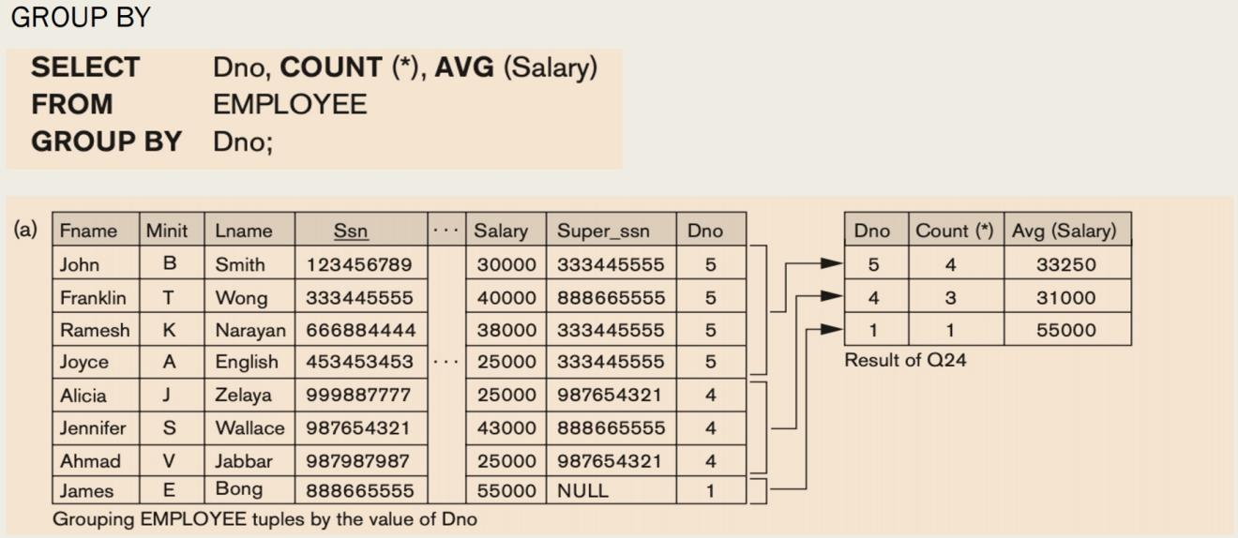

## HAVING

Provides a condition to select or reject an entire group, appear in conjunction with a GROUP BY clause.

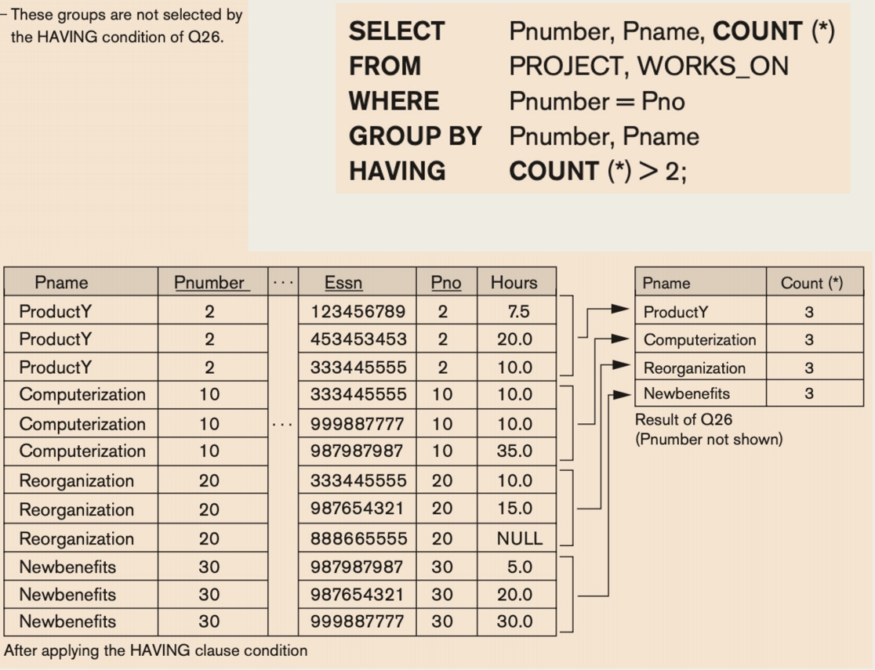

## JOIN Tables

### INNER JOIN

Tuple is included in the result only if a matching tuple exists in the other relation

### LEFT OUTER JOIN

Every tuple in left table must maintained in result. If no matching, padded with NULL values for attributes of right table

### RIGHT OUTER JOIN

Every tuple in right table must appear in result. If no matching, padded with NULL values for attributes of left table

## Views in SQL

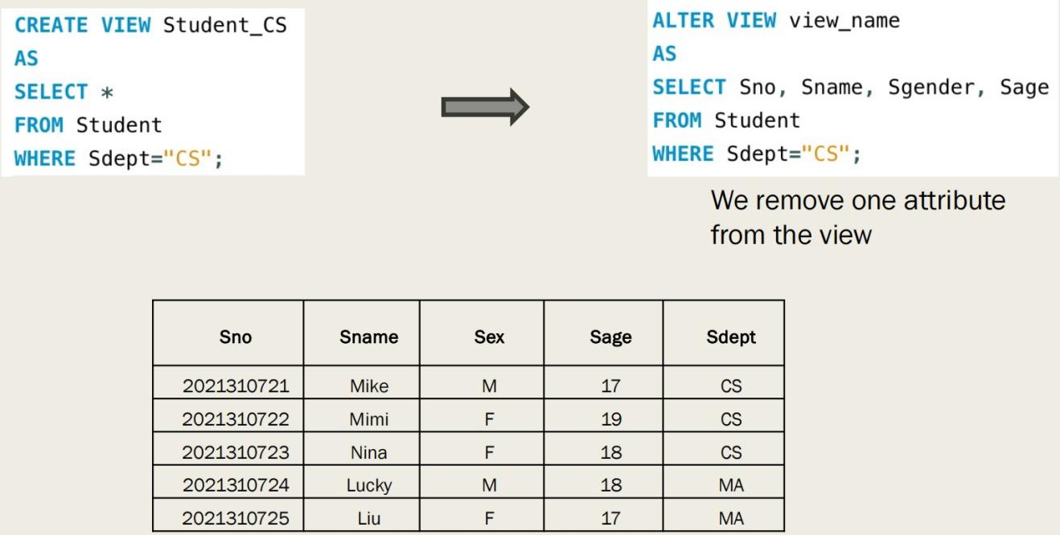

## Summary of SQL Syntax

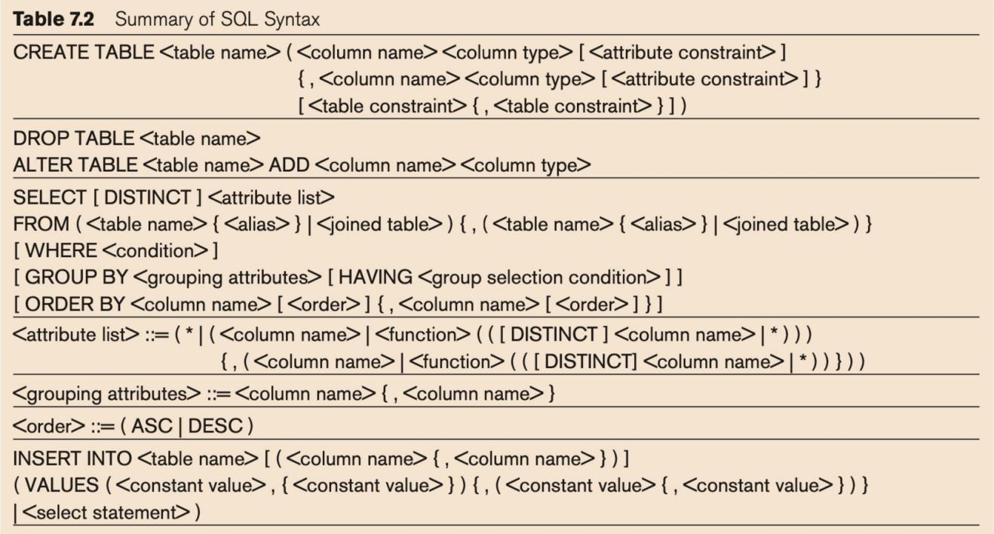

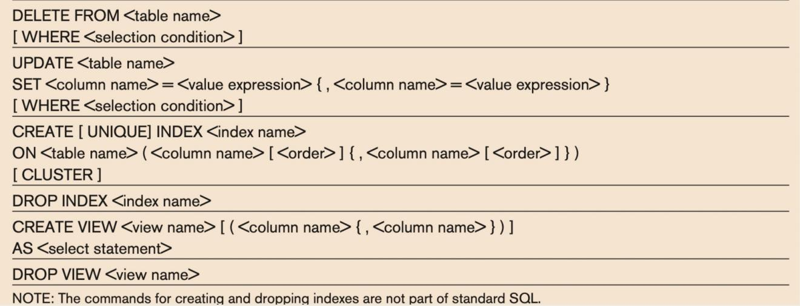

# Week 7 Lecture 6,7

## Relational Algebra

### Unary Relational Operations

SELECT (symbol: s (sigma))

PROJECT (symbol: p (pi))

RENAME (symbol: r (rho))

### Binary Relational Operations

JOIN (several variations of JOIN exist)

DIVISION

### Relational algebra operations from set theory

UNION ( È ), INTERSECTION ( Ç ), DIFFERENCE (or MINUS, – )

CARTESIAN PRODUCT ( x )

### Additional Relational Operations

AGGREGATE FUNCTIONS (These compute summary of information: for example, SUM, COUNT, AVG, MIN, MAX)

# Week 8 Lecture 8

## Functional Dependency

## Inference Rules for FDs

## Relational Database Design

1. Week 9 Lecture 9